1. Java program to find common elements from three sorted (in non-decreasing order) arrays

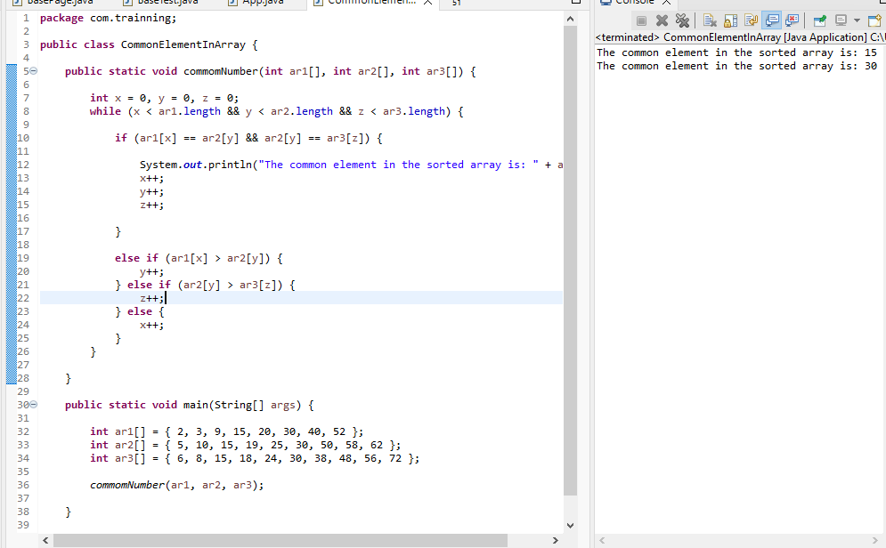

2. Java program to move all 0's to the end of an array. Maintain the relative order of the other (non-zero) array elements

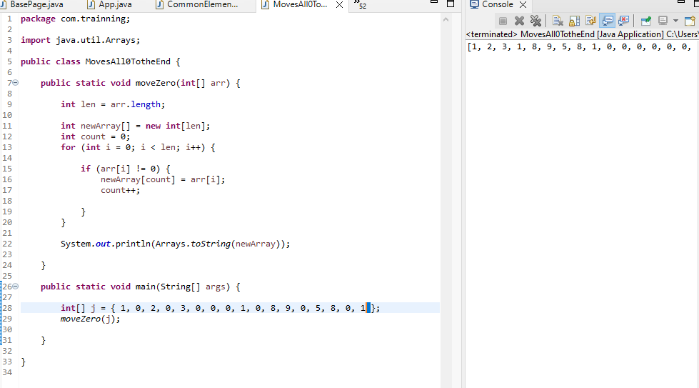

3. Write a Java program to find the number of even and odd integers in a given array of integers. 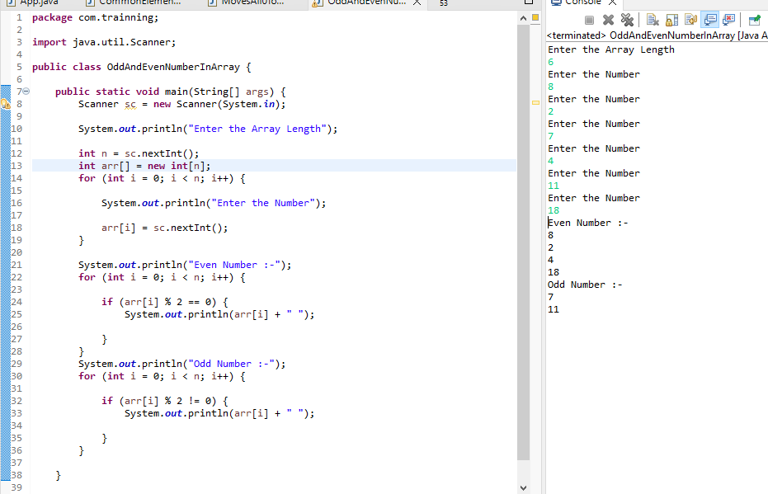

4. Java program to get the difference between the largest and smallest values in an array of integers.

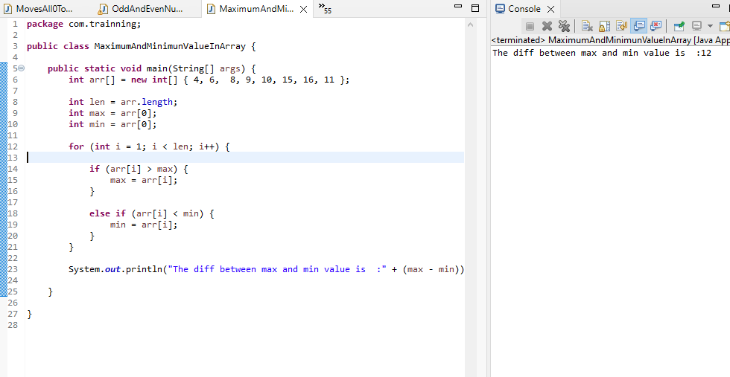

5. Write a Java program to compute the average value of an array of integers except the largest and smallest values

